
MOSMAN PROBUS NEWS
PO Box 264, Mosman NSW 2088 www.mosman-probus-club.com.au mosmanprobus@gmail.com
Fun and Friendship ABN: 96 728 384 926

OCTOBER 2026
Meeting on Wednesday, 28 October 2026
Newsletter photos to: margaret@cremorne1.com
-.-.-.-.-.-.-.-.-.-.-.-.-.-.-.-.-.-.-.-.-.-.-.-.-.-.-.-.-.-.-.-.-.-.-.-.-.-.-.
Meeting Apologies to be sent to: mosmanprobus@gmail.com OR 0478 051 950
Venue: Mosman Art Gallery Hall 10:30 – 12:30pm
Doors will open at 10:00am
Next Meeting: Wednesday, 25 November 2026
TODAY’S SPEAKER Heather Jenkins
Dr Lawrence Smith: “Reminiscences of an Old Dentist”
Lawrie’s commentary on his professional life and the social issues that he found significant over the decades from 1970.
This will be a shorter 20-minute presentation as there will be a
Members' Survey conducted after the Morning tea/coffee break.
Member’s 5-minute Spot: Margaret Szalay “Easter Island”

CLUB LUNCH AFTER THE GENERAL MEETING … YOU’RE INVITED
Members and guests are invited to join us at our Club lunch after each meeting, held upstairs in the Upper Duck Restaurant, Hotel Mosman, Military Rd, Spit Junction, (next to Boronia House), a short walk from the Mosman Art Gallery.
POSITION VACANT - Assistant Secretary  An interested Club member is needed to share the role of Club Secretary.  Talk to our Secretary about the role.  mosmanprobus@gmail.com OR 0478 051 950 | PROBUS COFFEE CATCHUP – Third Sunday of the month  10.30am, at Café Jam, upstairs at Bridgepoint  You are invited to get together for coffee and a chat on Sunday morning.  No need to RSVP. Just drop in if you are free.

PRESIDENT’S REPORT Peter Reeves
Our Newsletter, together with our website, is the main way we keep members informed about upcoming activities and Club news. It has a long history: our archives hold copies dating back to the Club’s earliest meetings, and it has changed and grown considerably over the years. Over the coming months you’ll notice some further improvements, including a fresh new look. The heart of the Newsletter will stay the same; we simply want it to be easier to read and to reflect how members get their news today. Thank you to Margaret Szalay for leading this work, and to the Management Committee and the many members who have contributed ideas. As always, we’d love to hear what you think once you’ve seen the changes.
I do have sad news to share with members. Ann Neill passed away recently. Ann joined our Club in 1991 and only relatively recently retired from active involvement. Ann was a Life Member, an honour our Club gives only for outstanding service. There is a formal club tribute to Ann later in this Newsletter.
On a happier note, our second Sunday morning coffee catch-up at Café Jam was a lovely, relaxed morning. Eleven of us came along, and it was a nice chance to chat in an informal setting. We’re planning to continue to arrange these get-togethers every third Sunday of the month at Café Jam at around 10:30 for members who would like to share a cup of coffee and a chat. So, keep an eye on the Newsletter for updates; reminders will be sent beforehand.
Christmas is closer than it looks, and planning for our Christmas Lunch on Wednesday 9 December is well under way. As last year, we’ll enjoy a traditional Christmas lunch and pudding with drinks included, plus lucky door prizes. If you haven’t booked yet, please reserve your seat at our next meeting. My thanks to Robyn, Sarnie and Heather for all their work so far; it promises to be a wonderful way to end the year. Before then, there’s still plenty on, including the Melbourne Cup Luncheon at the Upper Duck and a $2.50 outing to Cockatoo Island. You’ll find details of these later in this Newsletter, along with a preview of some of the activities planned for 2027.
I also wanted to encourage members to come along to our Trivia Nights which are held at Club Bradley on the first Wednesday of the month. It’s a fun night and I will be quiz master this time so you know the answers will be easy! Don’t forget Cinema Club on the first Monday either, a nice way to keep up with good movies and socialise with friends.
It’s been wonderful to see so many visitors at our recent meetings. If you’re one of them and you’ve enjoyed yourself, please have a word with Jenny or Keith, our membership secretaries, about joining. Visitors are welcome to come along to up to three meetings or activities to see what goes on, and after that we’d love you to become members.
That brings me to Committee positions. Every role falls vacant at the AGM in March, and nominations will be called. We’re particularly looking for help with the following positions: Treasurer, Membership and Assistant Secretary. If you’ve ever wondered how the Club runs, have a chat with any Committee member. Many jobs can be shared, and nobody is left to work it out alone.
Thank you, as always, to everyone who helps behind the scenes. This month, I’d like to acknowledge two of our hardest workers: Secretary Ian and Treasurer Helmut. Ian is still looking for an Assistant and Helmut is looking for someone to train to take over from him next year. Both deserve the thanks and appreciation of all members.

PROBUS TRIVIA NIGHT  Join us for Trivia Night on the FIRST WEDNESDAY of each month (except January), from 5.30pm at the Warringah Bowling Club (renamed ‘Club Bradley’), 74-82 Bradleys Head Road, Mosman. Stay on afterwards for dinner at the Club.  Quiz master: Peter Reeves par909@icloud.com | CINEMA CLUB at the Orpheum  We meet at 3pm on the FIRST MONDAY of each month (except January) at the Orpheum for the movie of your choice, followed by dinner at a nearby restaurant. Details are circulated on the previous Thursday.  Contact: gillnapper@gmail.com to join the list.

UPCOMING ACTIVITIES Robyn Yates
DETAILS, BOOKINGS & PAYMENTS AT ACTIVITIES DESK AT MONTHLY MEETINGS;
or BOOK & PAY BY E.F.T. to: Westpac Account: BSB: 032 097; Account number:750 233.
Account name: The Probus Club of Mosman Combined Inc.
[Identify deposit with your name & event, then email bank receipt to mosmanprobus@gmail.com]
Tues 3 Nov | Melbourne Cup Lunch at The Duck Hotel. Mosman  Arrive noon to12:30 dressed to celebrate the Cup & potentially win a prize. Join in the sweepstakes as you enjoy a drink on arrival. After a wonderful lunch, settle in to watch the Melbourne Cup on the big screen. A fun day with friends.  Cost is $86pp  Please note The Duck Hotel will not be providing TAB facilities for Melbourne Cup.
Wed 9 Dec | Christmas Lunch, Mosman Art Gallery.  Members & visitors are welcome to join old & new friends for a traditional Christmas. Canapes & drinks will be served on arrival at noon.  Following a special musical performance, a traditional 2 course Christmas lunch with drinks will be served by a new caterer recommended by the Gallery.  Be in the chance to win some lucky door prizes.  The cost of $85pp is inclusive of all food & drinks. The event is subsidised by Mosman Probus to encourage everyone to come & celebrate together.

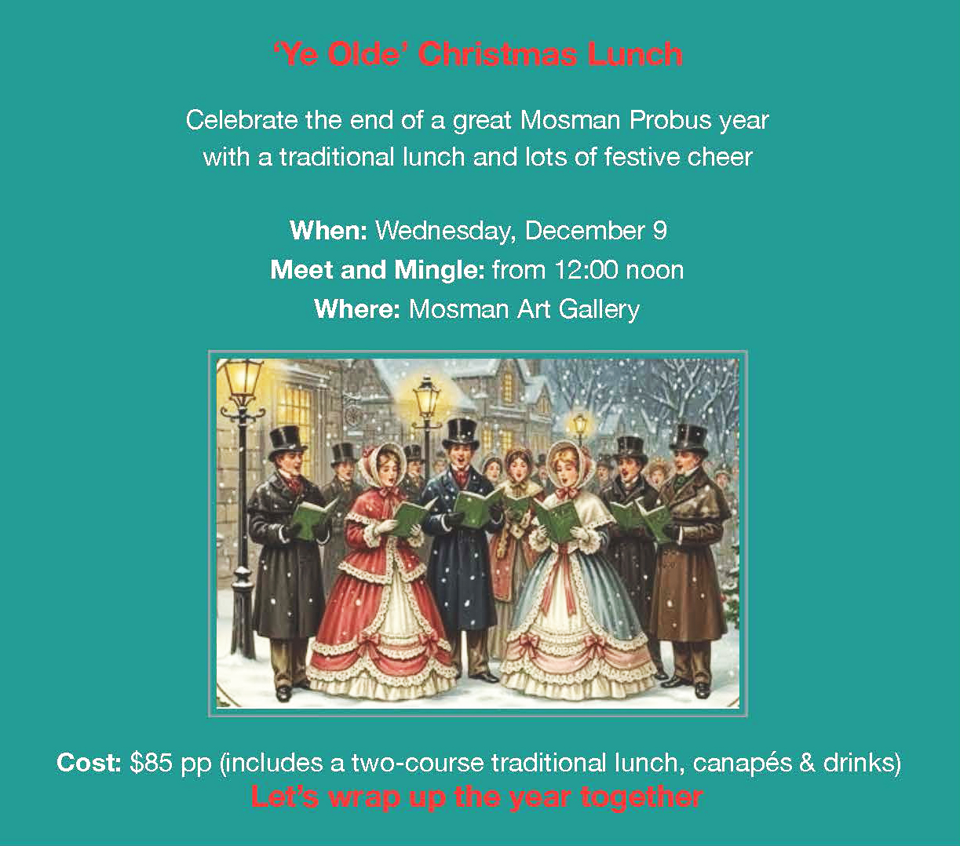
MORE UPCOMING ACTIVITIES Robyn Yates
 | 2027
Wed 13 Jan | Welcome to 2027 - Picnic at Balmoral Beach  Join us to celebrate the new year with friends & get to know new people who are interested in our Club.  At 5pm we will be at the table under the big tree at the south end of the beach, between the sailing club & the water. Please bring your own picnic & drinks but feel welcome to share pre-dinner nibbles.  If possible, bring your own chairs & perhaps a table. If you have additional folding chairs or picnic tables please bring them to assist others.
Fri-Fri 14-21 May 2027 | Outback Opera Central Queensland & Farmstay (Taylor Made Tours)  Only 2 rooms remain for this 8 day, 7 night tour including return flights with Qantas Sydney/Longreach/Sydney; accommodation; 3 meals on most days plus morning teas; entrance fees to all tourist attractions & tours as per Itinerary; luxury air-conditioned coach travel; & fully escorted by Adam and Tania Taylor.  Enjoy Queensland Opera’s Open Air Opera in The Outback, visit the Stockman’s Hall of Fame, Thompson River Sunset Cruise & Dinner Show, Qantas Heritage Museum, Journey through Cobb & Co country, Deluxe Farmstay Experience at Toogunna Plains (5th Generation Sheep Property), Charleville Cosmos Centre & Secret WW2 Base tour, Blackall Wool Scour & the Sale Yards Tour, Barcaldine Tree of Knowledge & The Australian Heritage Workers Centre. Ilfracombe Machinery Mile, Eromanga Natural History Museum & more.  Cost is $5,695pp with $890 single supplement. Only 2 rooms are still available. Speak to Dawn at the Probus meeting for further information.

Outback Opera – A Review
On our May 2027 Outback Opera Tour with Adam & Tania Taylor, we will experience one of the two premier outdoor performances from Opera Queensland’s 2027 Festival of Outback Opera. British Baritone Sir Simon Keenlyside CBE will headline the Singing in the Night concert at Camden Park Station, outside Longreach. Sir Simon Keenlyside CBE will appear with Opera Queensland artists and the Queensland’s Chamber Orchestra.
A review of Queensland Opera’s 2026 program confirms that participants will be in for a treat. Pauline Webber ‘s review in a recent article of the SMH Traveller magazine said “On these stages, set against boundless skies & vast stretches of desert, the music is reshaped by the landscape, creating a visceral connection that both dramatic & moving.”
“Watching this year’s headliner, rising tenor Filipe Manu, sing against a blood-red sky bruised with sheets of gold & purple is truly memorable.”
While the Singing in the Night concert will be a highlight, the tour has a diverse range of activities including the Stockman’s Hall of Fame, a sunset dinner cruise, a farm stay, a secret WW11 base & the Charleville Cosmos Centre- something of interest for everyone.

MORE UPCOMING ACTIVITIES Robyn Yates
Sun-Fri 7-12 Nov 2027 | The Life of Riley Alpine Tour – highly recommended by members  Travel to & from Jindabyne by coach. Each day local guides will lead coach tours which include Snowy Hydro Discovery Centre, Adaminaby, Snowy Mountains Scheme Museum, a tasting at Wildbrumby Distillery, Dead Horse Gap, Thredbo Village, Gaden Trout Hatchery, Smiggins, Charlotte’s Pass, Cooma Goal, Berridale Historical Society, Dalgety & the Eucumbene Dam. One afternoon is set aside to explore Jindabyne.  The tour is inclusive of coach travel, accommodation at Lake Jindabyne Hotel, all meals (except lunch travelling from Sydney) & local guides who are passionate about the history & the area in which they live.  Cost is $1400 pp with no single supplement. Of the 16 rooms available only 10 are dedicated single rooms. Deposit required to hold the booking as these tours book out very early.  Due to the demand from the general public, we need to confirm booked rooms asap. Names will be collected at the meeting.

$2.50 CLUB OUTING Pamela McLeland
Wed  11 Nov. | Cockatoo Island Tour – led by Don Napper  We will meet at Circular Quay outside the entrance to Wharfs 4/5 at 9:30am to catch the 9:45am ferry to Cockatoo Island. A ferry from Mosman Bay leaves at 8:54am and arrives at Circular Quay at 9:14am, allowing time for a quick coffee before boarding the ferry for Cockatoo Island, where admission is free.  Our visit to Cockatoo Island will explore the Island’s three different historical phases. Starting in 1839, Cockatoo Island was initially used for 70 years as a prison. After the prison closed, the Federal Government in 1913 bought Cockatoo Island from the NSW Government to become the dockyard for the Royal Australian Navy. The dockyard closed in 1991 after building more than 50 naval vessels for the RAN. The Sydney Harbour Federation Trust has subsequently aimed at transforming the Island into an international Arts precinct.
NEW MEMBERS Peter Reeves
We welcome two new members, inducted at the Probus meeting on 23 September.
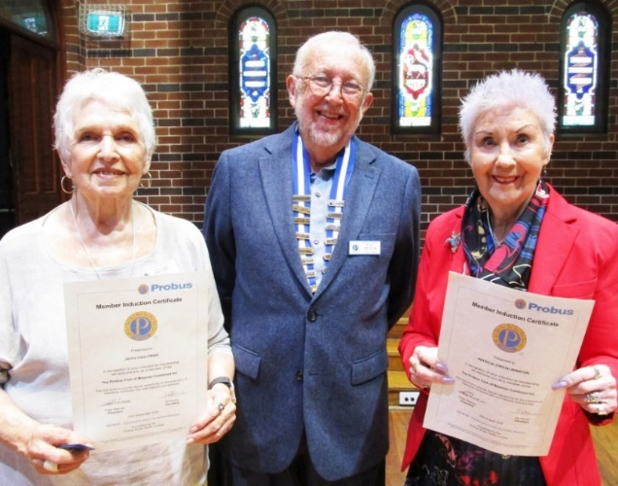 | Janice (Jan) Friso (left)  Jan was a registered nurse working in developing countries with my first Canadian husband for 19 years.  Her interests and hobbies: Tennis, pickle ball, reading, having homestay students from Japan, Gym. She has been a member of Mosman Senior Centre from 2022 - present.  She heard about Probus from her late husband Dave Henry.  Patricia (Tricia) Winston.  Tricia migrated from the UK 2010 with her husband spent a long time as a doctors PA, and was involved with Victim support as a volunteer. They spent 5 years in Saudi Arabia before moving here to be near family.  Interests and hobbies: Reading, walking, and generally getting to know Australia. She is also closely involved in her church. (Vichy encouraged her to come)
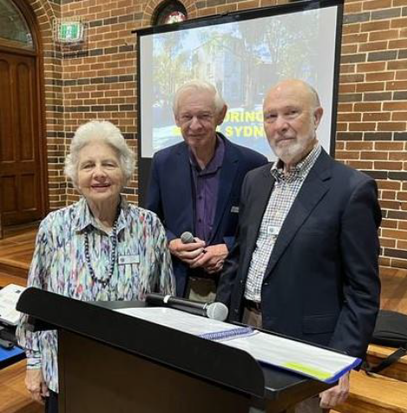  Ann receiving her Life Membership in 2023  (photographed with fellow Life member, Barry Starr & President, Vic Nevill) | VALE ANN NEILL OAM  The Club has been advised of the sad passing of longtime member, Ann Neill. Ann, with her husband, Ian, joined Mosman Probus in 1991. Ian was Club Treasurer 1998-2000, and President in 2001/02. Ann managed the Club’s outings from 1993 to 1997, and introduced our popular January picnic at Balmoral.  Following Ian’s death in 2016, Ann remained a regular member of the Club and was awarded a 30-year pin and Life membership in 2023 for her contributions to the Club.  At the invitation of her family, members of the Club attended her recent memorial service held at St Luke’s, Mosman, on Thursday, 8th October 2026.
RECENT CLUB ACTIVITIES Sarnie Hay
21-25 September – A Taste of Canberra in Bloom (with OnCourse Tours)
Coins, Democracy, Trees, Tapestries and Tulips.
Twenty seven members from Mosman and Bobbin Head Probus escaped Sydney to settle into five days and four-nights of timeless charm at the heritage-listed, Hotel Kurrajong as Canberra’s living history unfolded around us. We visited Old Parliament House with its stark white facade that earned it the affectionate nickname of The Wedding Cake” to the Royal Australian Mint to watch coins being struck before exploring the National Arboretum with its more than 250 forests of rare and endangered trees from around the world. I think it is fair to say that there was not a dry eye as we watched the Last Post Ceremony at the Australian War Memorial.
If the piece-de-resistance of the trip was our visit to the National Gallery to see the twenty monumental tapestries commissioned by Arthur Boyd—then the showpiece of the tour would have to be Tulip Tops with its 10-acre wonderland of stunning gardens framed by weeping willows, and 1,000 blossoms that paint the scene for almost a million tulips, daffodils and other flowers creatively planted. Happy hours at the Kurrajong were the antidote to a busy end of day bus trip. Our journey home included morning tea at Blackwattle Alpaca Farm and lunch at a local winery. Thank you indeed to Robyn and Ros for all their care and attention resulting in another delightful combined club trip.
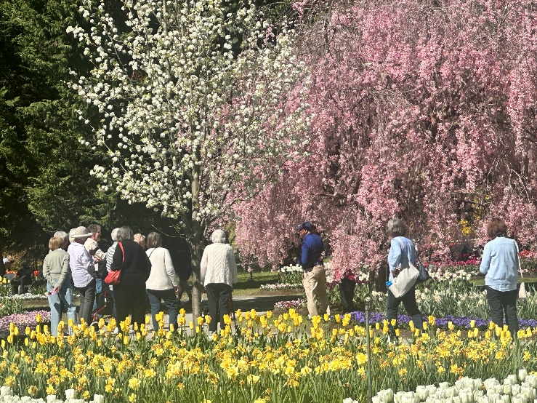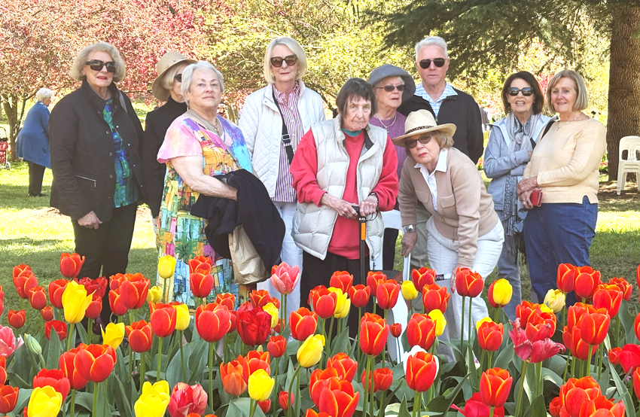
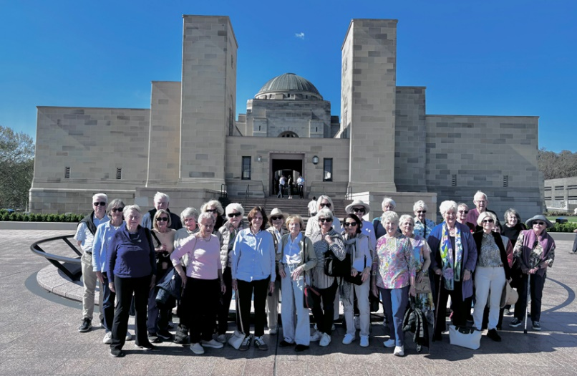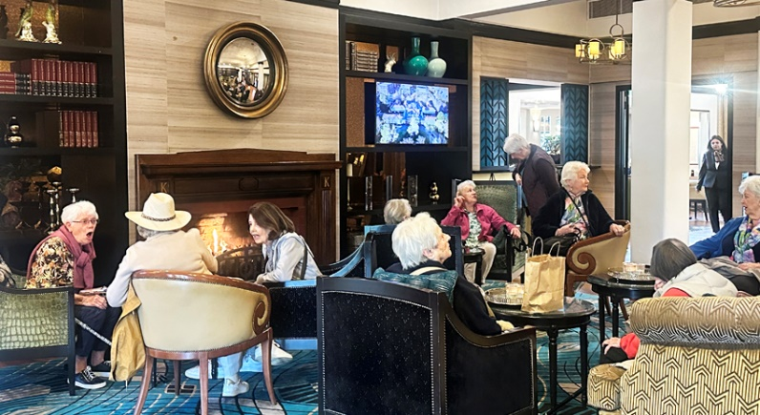
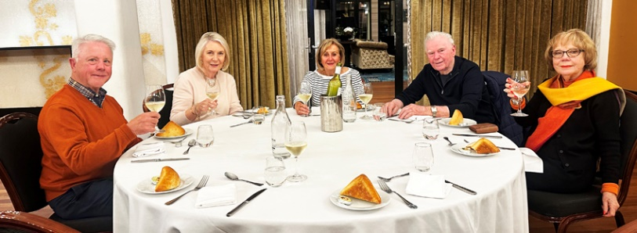
Photographs from Robyn Yates
RECENT $2.50 CLUB OUTINGS Pamela McLeland
Thursday, 8 October – Jazz Concert at the Sydney Conservatorium of Music
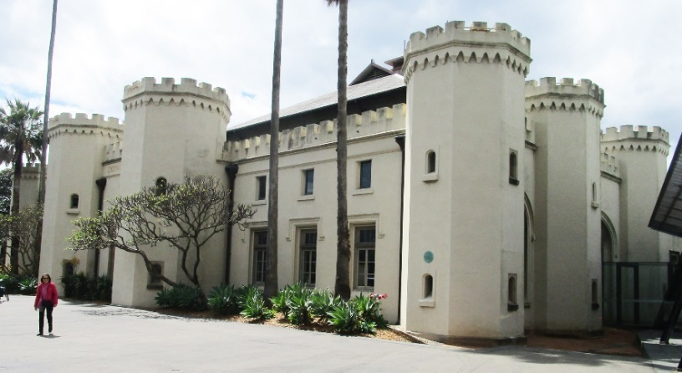  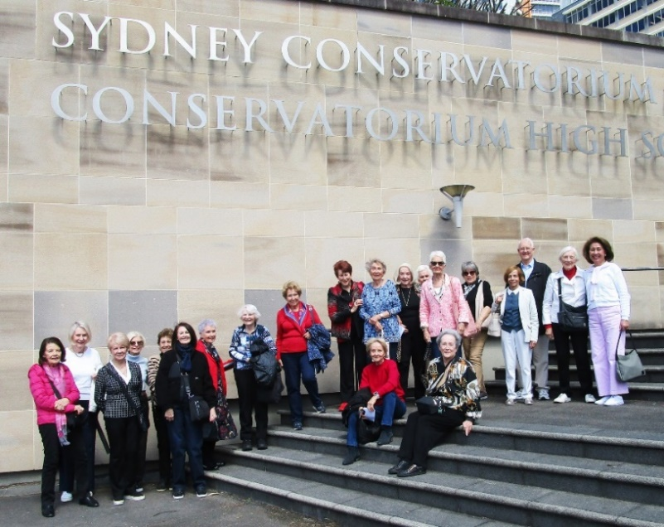 | On Thursday 8th October, a large group of 21 members and friends met at the Conservatorium of Music to attend a jazz concert put on by the students.  The talent on show was amazing – one piece was written by a student and blew us away. The young vocalist did a great job and the conductor was also entertaining. Admittance was by way of a gold coin.  A return trip has been suggested, maybe a symphony concert next time. This can be done in the new year.  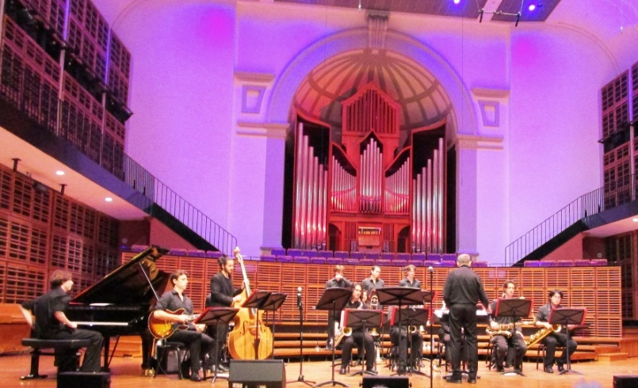  (Photographs by Margaret Szalay)

SPEAKER IN AUGUST: Peter Reeves
Rosanna Commisso, Road Safety Officer at Mosman Council:
Pedestrian Safety for Seniors
Rosanna, Mosman Council’s new Road Safety Officer, gave a lively and interactive talk on staying safe as a pedestrian. She had been in the role only a month and brought a background in community education and behaviour change. The statistics were sobering. In 2024, around 40% of pedestrians killed on NSW roads were over 60, and older pedestrians are far more likely to die when hit. Pedestrians were involved in a surprisingly high share of Mosman’s crashes, well above the state average. Most incidents happen on ordinary local two-way streets between 2pm and 6pm, when everyone is on the move. Speed matters enormously. A pedestrian hit at 40 km/h has a reasonable chance of surviving, but at 60 km/h the odds collapse to around 15%.
Rosanna explained why we become more vulnerable with age. It gets harder to judge vehicle speed, our eyesight, hearing and night vision decline, our necks turn less freely, and our reactions slow. Members added their own observations, including a tendency to look down while walking and growing impatience at traffic lights. Silent electric cars and bicycles were a particular concern. She urged regular eye and hearing checks, and reviewing all medications with a doctor or pharmacist, including over-the-counter remedies, since they can affect alertness and balance. Her practical tips were to wear bright colours (fluorescent giveaways were on offer), wear sunglasses against glare, keep dogs on a short lead, pause at every driveway, and never assume a driver will stop. That last point applies even at a green “walk” signal.
Traffic lights and pedestrian bridges are the safest places to cross. Pedestrian refuges let you cross in two stages, but cars are not required to stop there. Be wary of crossing on bends, near the crest of hills, behind buses or between parked cars. Rosanna also encouraged us to offer a steadying arm to anyone struggling to cross in time, and to accept help without embarrassment. Her message boiled down to four words: Stop, Look, Listen, Think. Road safety concerns in Mosman can be reported to Council.

“BRING A FRIEND” PROMOTION

At the June meeting, Sarnie Hay, on behalf of the Club’s Publicity team, announced the Club’s plans to encourage current members to bring along a friend or neighbour as a visitor to our monthly meetings to expand our membership. At the annual Christmas lunch in December, the names of the participating members will be placed in a ‘hat’ and a winner drawn, to receive free membership for the following year (no subscriptions!!).
p

YOUR COMMITTEE & VOLUNTEERS
President: Peter Reeves  0416 496 505  Vice-President: Lynette Armstrong  Secretary: Ian Hume  0478 051 950  Treasurer: Helmut Regelein  Immediate Past President:  Rob Taggart  Club Ambassador: Barry Starr  Public Officer: Lawrie Smith  Financial Reviewer: Rob Brown  Greetings Team: Keith McDonald  Jenny McDonald  Sally Cullen | Membership:  Keith McDonald  Jenny McDonald  Team: Sally Cullen  Mona Deakin  Jenny Reeves  Christine Fraser  Desley Hume  Denise Bloom  Activities: Robyn Yates  0407 432 642  Team: Monica Anastasia  Sarah Fennamore  Dawn Willis  Sue Hartmann | Speakers: Heather Jenkins  Newsletter: Margaret Szalay  Don Napper  Welfare Officer & Probus Cluster:  Margaret Badger  Publicity Team: Sarnie Hay  Heather Jenkins  Dawn Willis  Book Exchange:  Vichy Clapano  Cinema Club: Gill Napper  Club Lunches: Jennifer Walker  Morning Tea: Ashlear Britt  Jenny Cottrell

